**Research Flyer Help Guide – Getting Started**

Go to the library website: <http://library.missouristate.edu>

Click on Articles & Databases under Find:

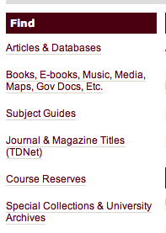

Click P and scroll down to PsycInfo

(Note: if you are off campus, you will have to log in with your bear pass).

In EBSCO click on Advanced Search under the search bar.

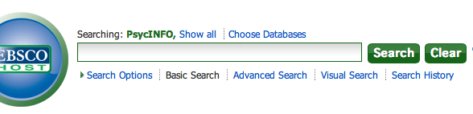

­

Type a search term in the box(es) at the top.

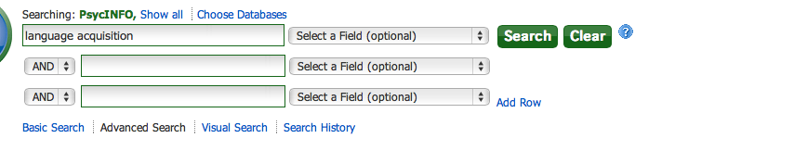

Scroll down to limit your results and click Peer Reviewed on the right side. You can also click full text to only see articles we have easy access to.

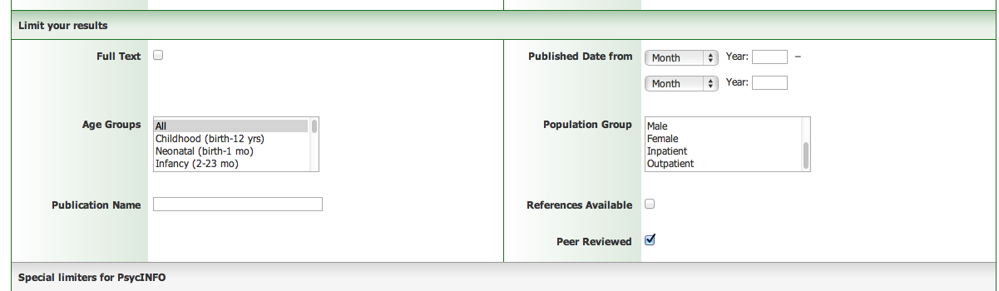

Under special limiters for PsycINFO

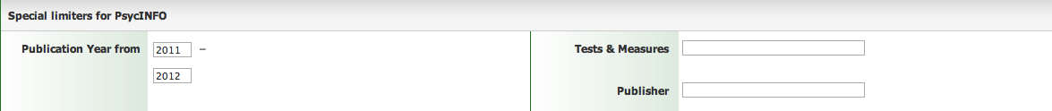

Type in 2012 to 2015 in the publication year.

Then under Methodology click on EMPERICAL STUDY



Hit search to get results!

**Google Scholar**

First: if you are off campus, sign into the university VPN (if you are on campus, you can skip this step).

Go to: <https://passport.missouristate.edu/+CSCOE+/logon.html>

Log in with your university bear pass + password.

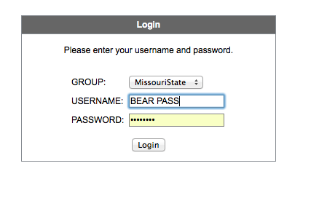

Sometimes, this site does not work. You will be instructed to download the Cisco VPN client. Here’s the help site for VPN questions: <http://helpdesk.missouristate.edu/connectivity/off-campus/vpn>

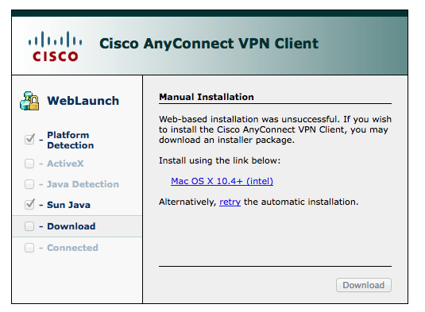

Once you get logged in, go to: <http://scholar.google.com>

Why go to all the trouble? Because when you are logged into the campus server, Google Scholar connects you to the campus resources we have (aka PDFs!).

Search google scholar for your topic.

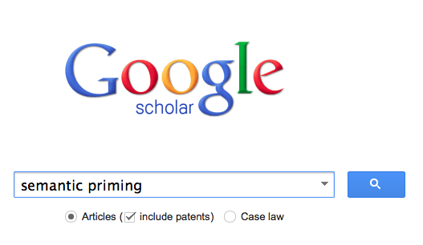

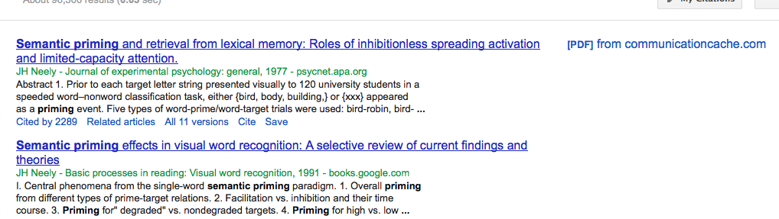

Things with PDF on the side are downloadable. But if you click on the link for these sites as well, you can usually get connected through what our library offers. You will have to determine if an article is empirical / has participants by reading the article, rather than the search options above. You might be able to find an article listed in the EBSCO system, and then search Google Scholar and find the PDF.

Library website for distance learning tips: <http://guides.library.missouristate.edu/content.php?pid=265766&sid=2194253>